

**CIS 11042 – Practical for Essential of ICT and PC Applications**

Information and communication Technology

Faculty of Technology

South Eastern University of Sri Lanka

Registration Number: SEU/IS/22/ICT/075

Academic year: 22/23

LabSheet: 15

**Title**: MS Power Point (Power Point basics, working with slides and text)

**Aims:**

* Make familiar with MS Power Point 2019 interface.
* Power Point basics.
* Working with slides.

**Tasks**

1. Introduction to Power Point 2019 interface and backstage view.

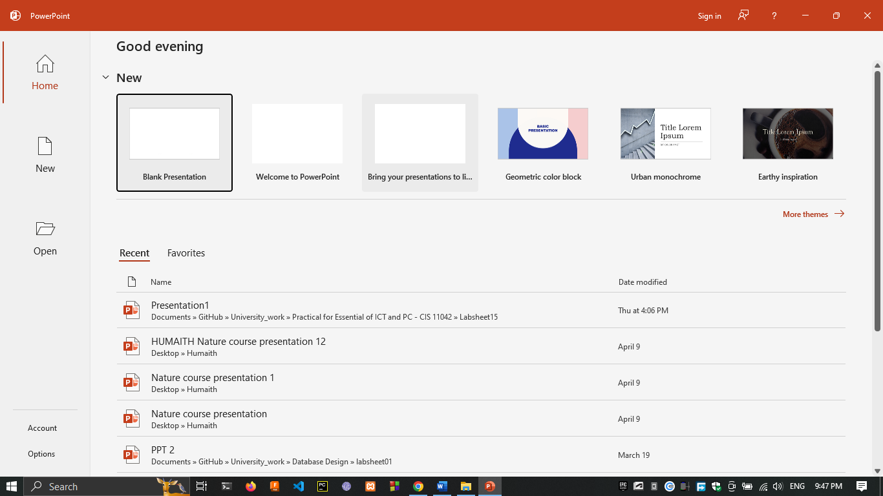

1. Select Blank Presentation.



1. More themes 🡪 select any temples from list 🡪 create.

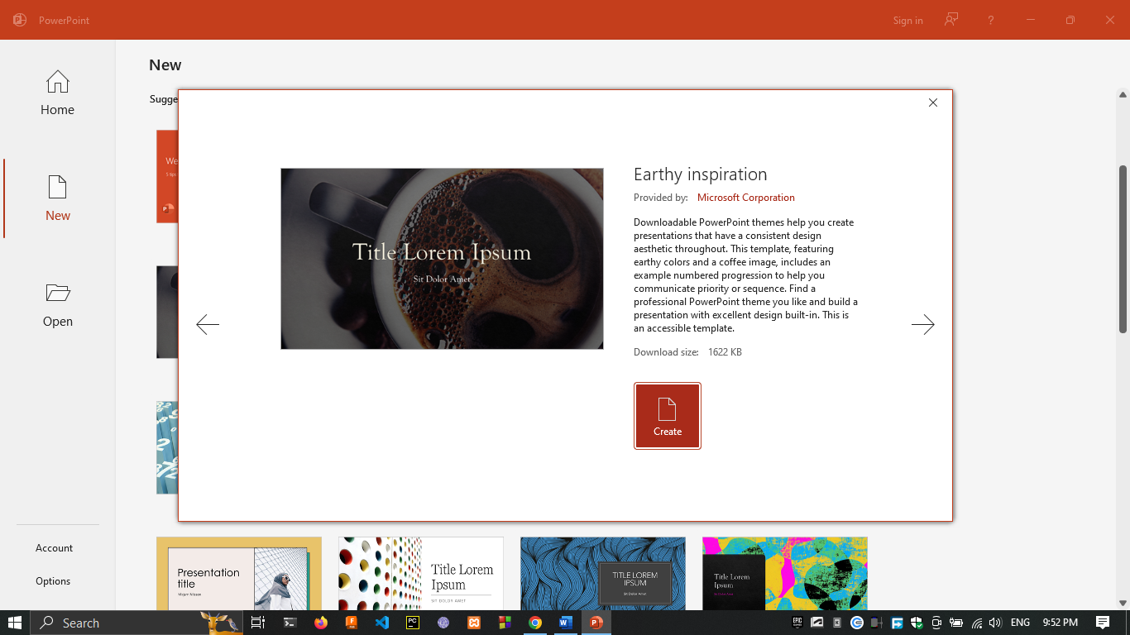

1. Opening an Existing Presentation.

